Event Sourcing

# Workshop

## Pre-clinical studies & Animal research

Our company develops new drugs. During the phase of pre-clinical studies of a new drug we experiment with animals. Most of our animals are mice or rats. Most of the time our animals are kept in special cages inside an animal facility. Caretakers look after them and veterinarians are responsible for their health. Usually we have 3-5 animals in a cage. Cages are organized in racks. A typical room can contain many racks.

Selected vendors deliver the ordered animals to the docks of our facility where specialized personnel receives the animals and puts them into cages. That’s also the moment when we start tracking an animal.

When lab personnel need animals they get them from the animal facility and book the cage out. This is important to know since we have to pay the facility management for their care taking a certain amount per cage and per day. We have to pay the facility management monthly for all our animals and the money is deducted from our grants that we got for our scientific research.

## Operations

We envision that the following features are available through the application

* Receive a batch of animals and put them into cages
* Move cages to target location in the facility
* Move cage(s) to a different room/location
* Transfer animal(s) from cage A to cage B
* Book cages in and out
* Measure the weight of an animal
* Measure the size of an animal
* Assign an optional nickname to an animal

## Reporting

Reporting is very important for our company and we envision that this new application provides us a lot of new insight into our business processes. Thus we expect that the application can at least provide reports for the following

* The full history of an animal as it was entered into the system in chronological order
* Humans make mistakes and thus we want to be able to fix our mistakes retrospectively. We want to see the true history of an animal considering the retrospective changes
* Room occupancy over time
* Chart of the weight of an animal over time
* Chart of the size of an animal over time
* Accrued cost for caretaking per room. Note that each cage type has an associated cost per day.

## Data

We expect to see the following attributes per animal: ID, nickname, cage ID, gender, species, weight and size.

We expect to see the following attributes per cage: ID, cage type, location, status (IN/OUT)

# Architecture

We are going to use Event Sourcing (ES) as architectural pattern. We also use CQRS, that is we keep our commands and queries strictly separated.

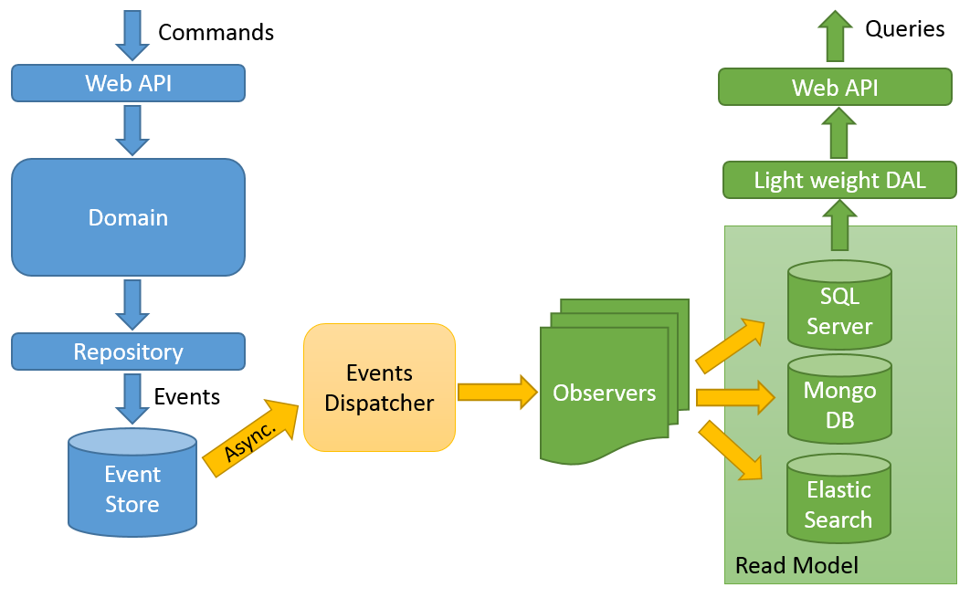

# References

Articles about CQRS and Event Sourcing

* CQRS revisited: <https://goo.gl/ZvwE0X>
* CQRS applied: <https://goo.gl/yxjKkG>
* Event sourcing revisited: <https://goo.gl/f1cNB4>
* Event sourcing applied: <https://goo.gl/mXm2gq>